
User manual for Administrator
Version 1.0
By Gurvinder Kaur

Table of Contents
Introduction 3
Login 3
Create Staff Account 4
Add New Service 5
Update Service 6
Delete Service 7
Update buttons on Order page 8

Introduction
This document is a user manual targeted at the administrators at Hobbs Dry Cleaners and Launderette.
Please note: Administrator has to successfully login before they can access the Administrator Panel from where they will be able to carry out the administrator functions.

Login
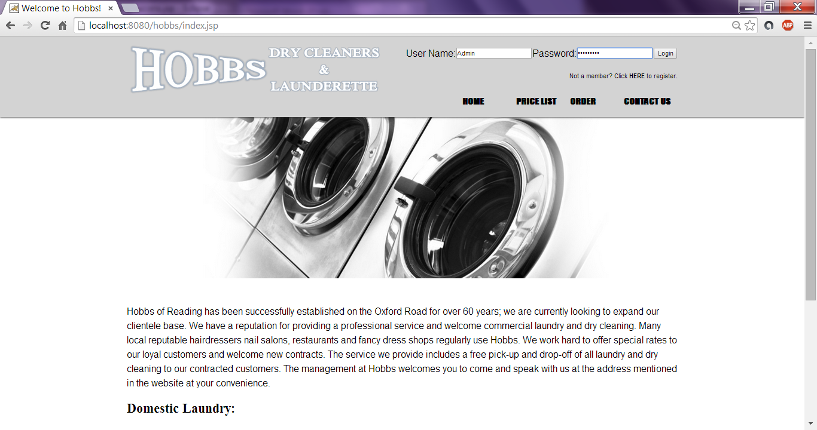
- Visit www.hobbsofreading.com to access the Hobbs website.
- Enter valid administrator credentials and click on Login

Create Staff Account
- Click on ---CREATE STAFF ACCOUNT--- on the Administrator Panel.
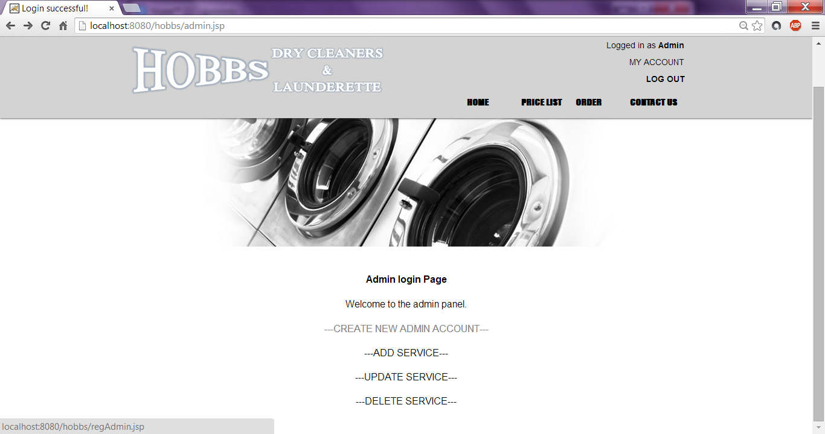
- Fill in Administrator Registration details and click on Submit
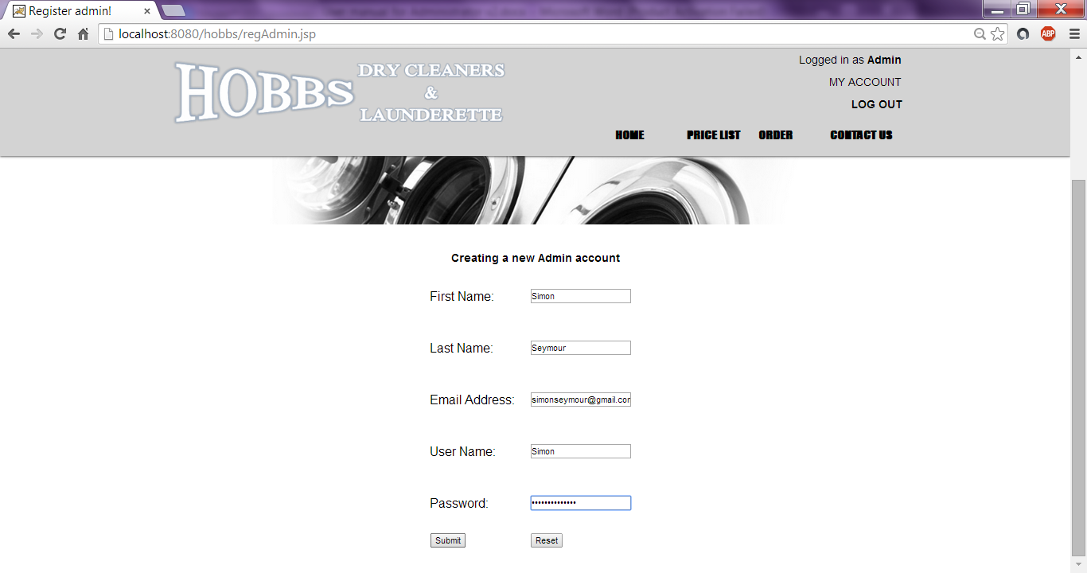

Add New Service
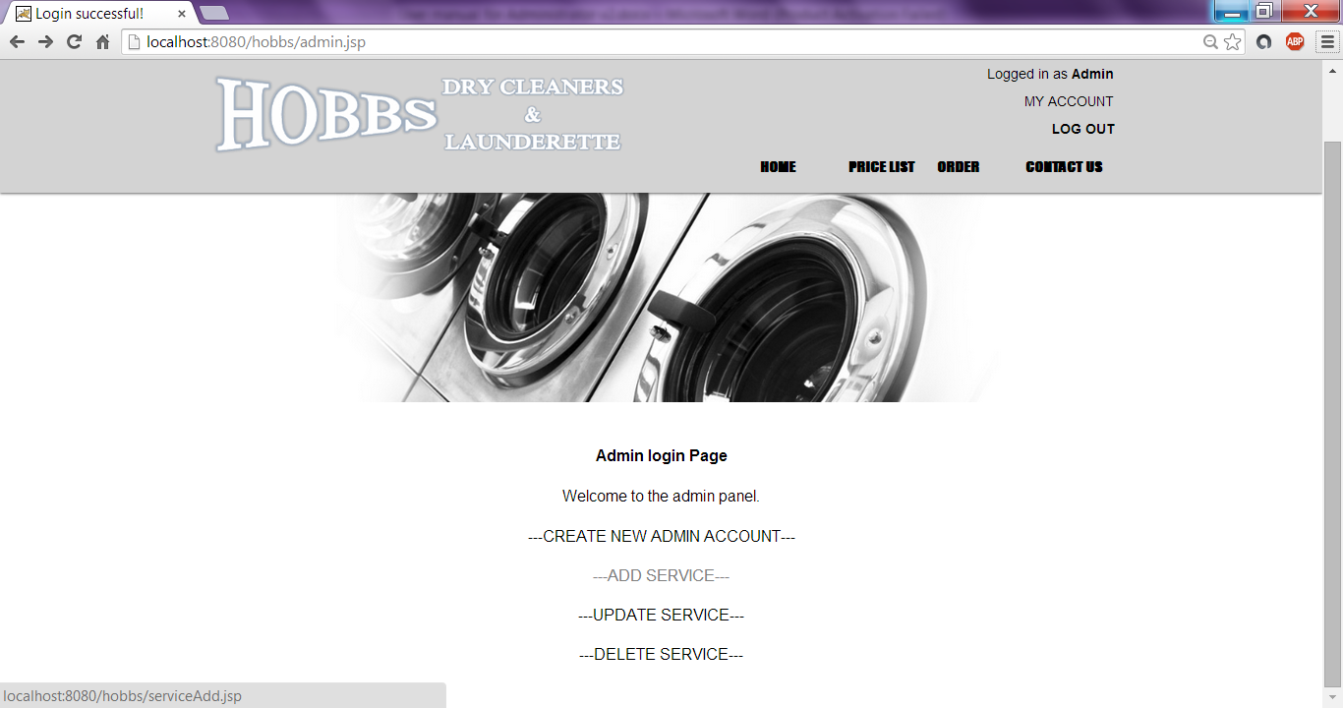
- Click on ---ADD SERVICE--- on the Administrator Panel
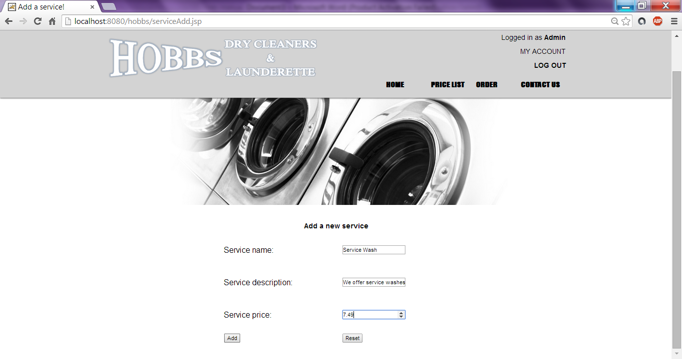
- Fill in the Add Service form and click on Add
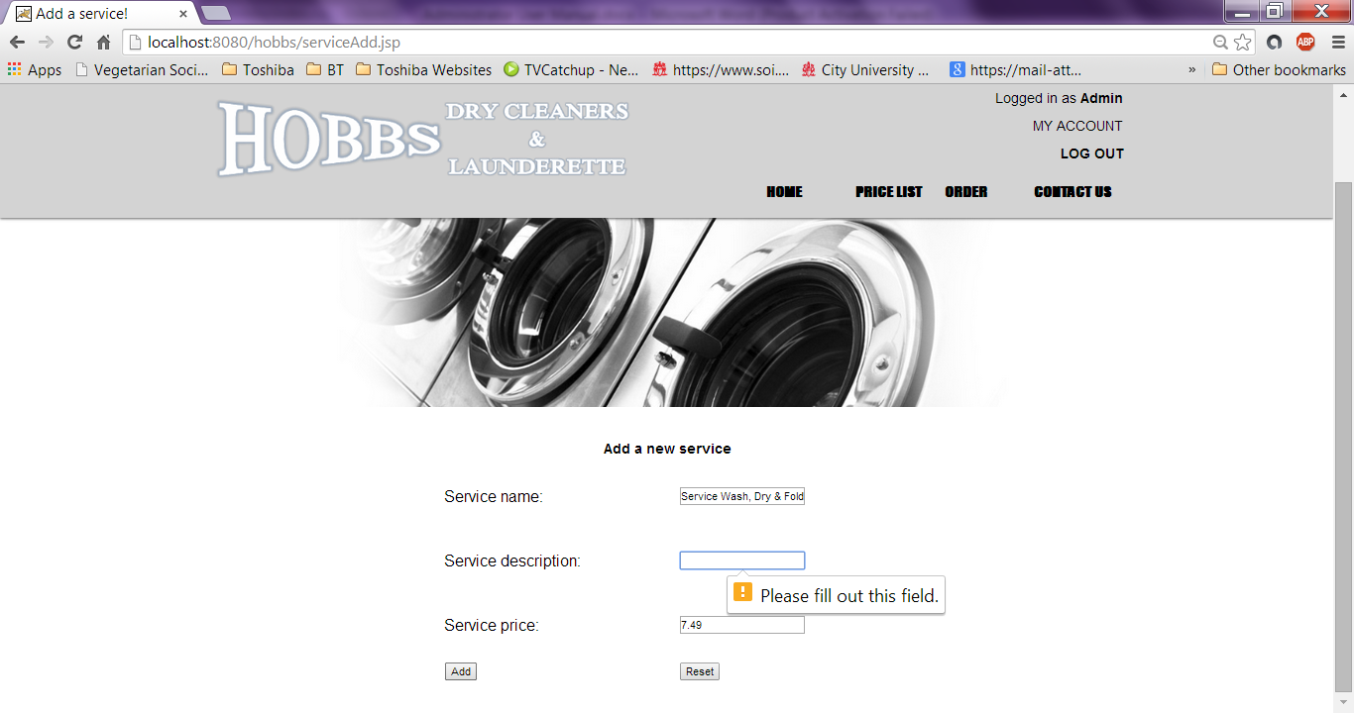
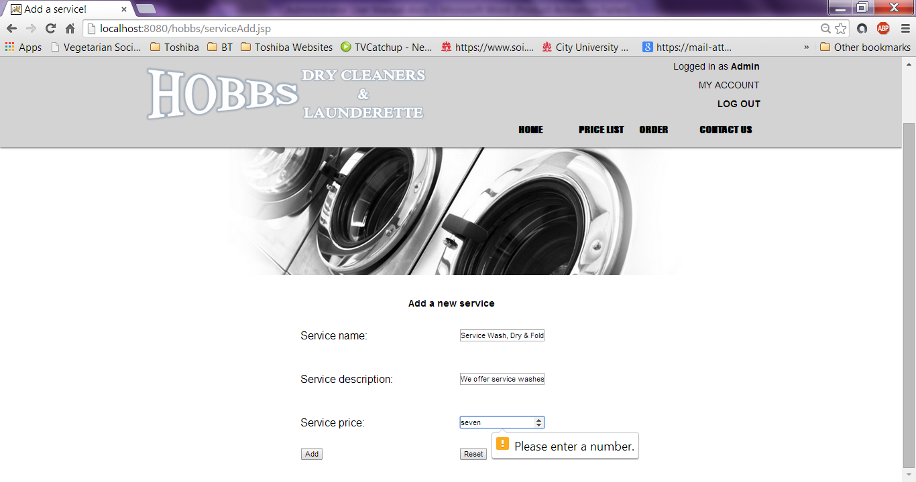
Please note: The user must fill in all boxes as well as enter the correct content in all boxes. (When entering a Service Price, the user must enter a number to continue with adding the service) Otherwise a warning would display notifying the user.

Update Service
- Click on ---UPDATE SERVICE--- on the Administrator Panel
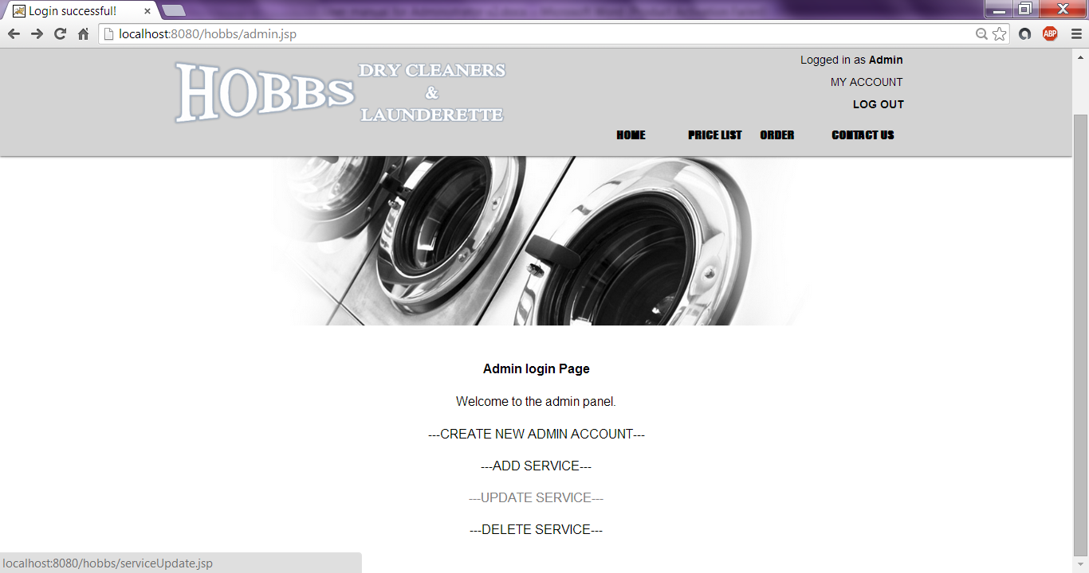
- Fill in the Update Service form and click on Update.
(Use the table on the bottom half of the page to find the Service ID)
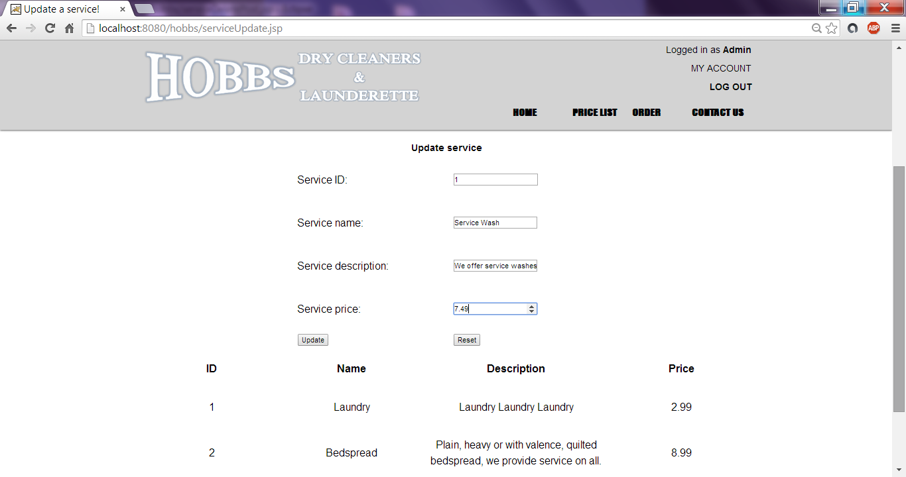

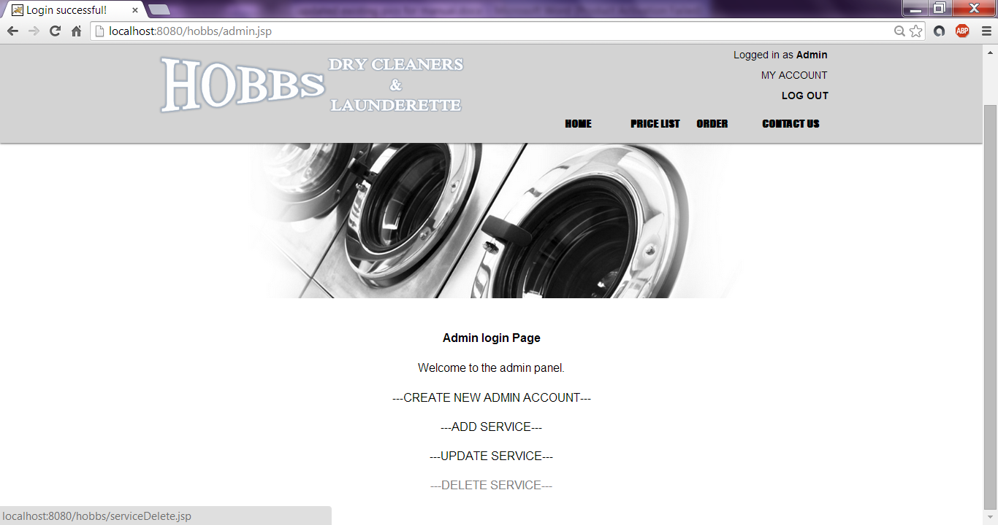
Delete Service
- Click on ---DELETE SERVICE--- on the Administrator Panel

- Fill in the Service ID of the Service you want to delete and click on Remove
(Use the table on the bottom half of the page to find the Service ID)
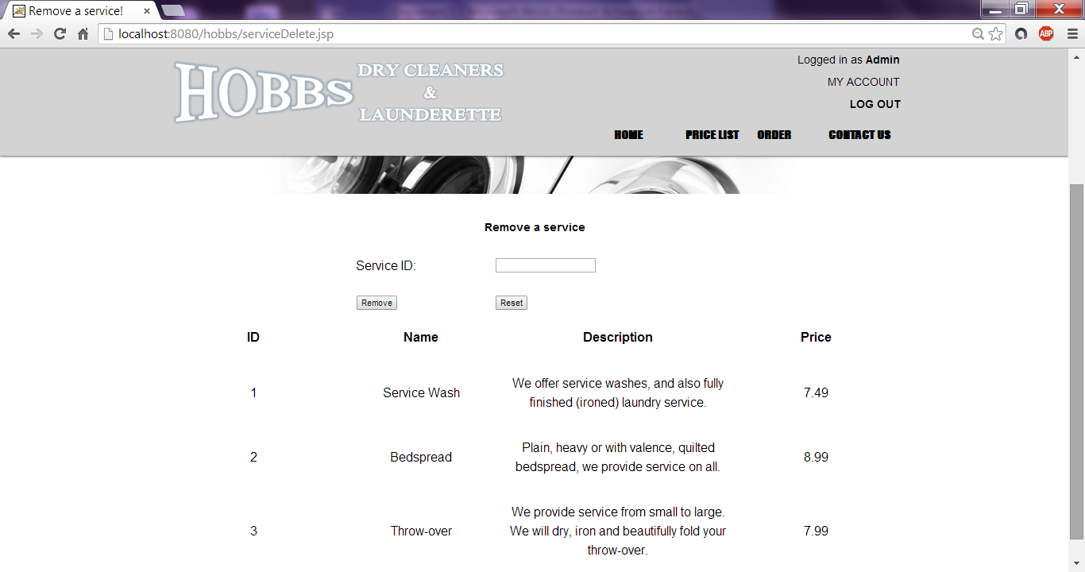

Update buttons on Order page
- To edit prices including drop down list which is displayed on the Order page, the user needs to visit www.PayPal.com. The user should log in with the business email address.
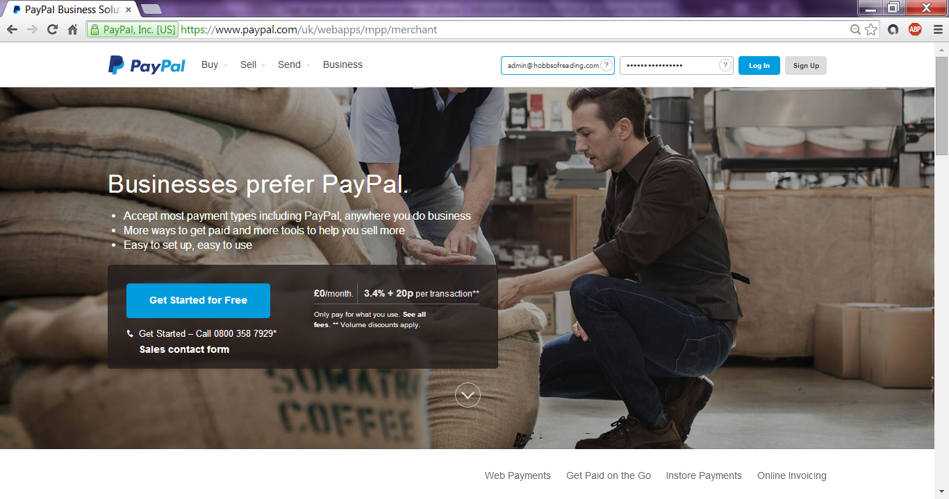
- The user will need to click on the user icon in the right top corner and click on Business Setup.
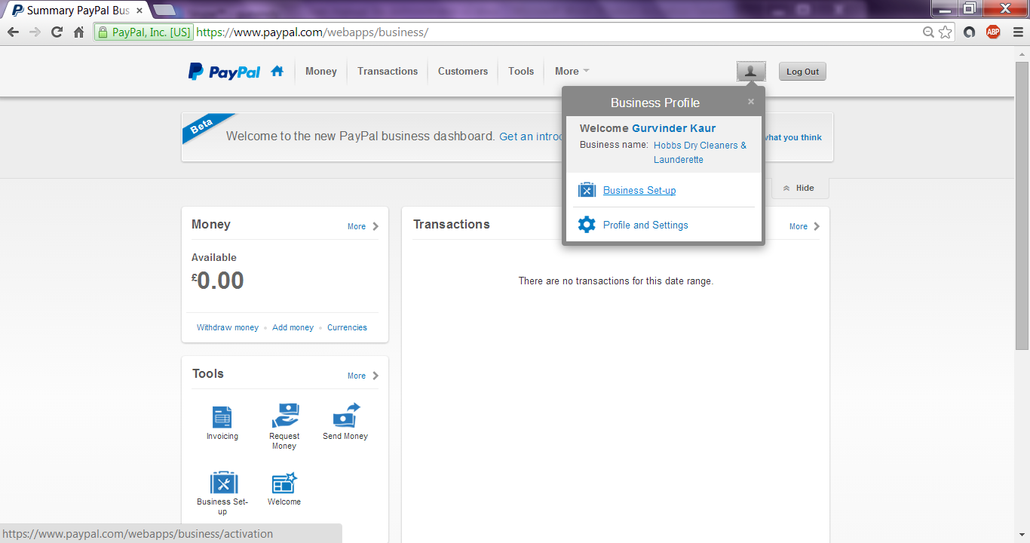

- Click on My Saved Payment Buttons on the right side of the list.
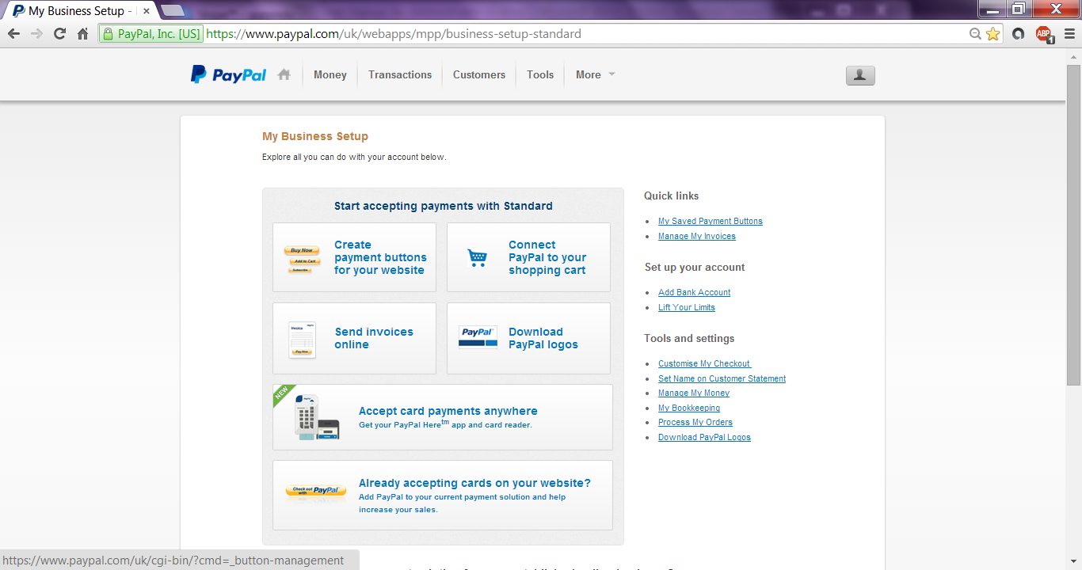
- Click on Action, then Edit Button
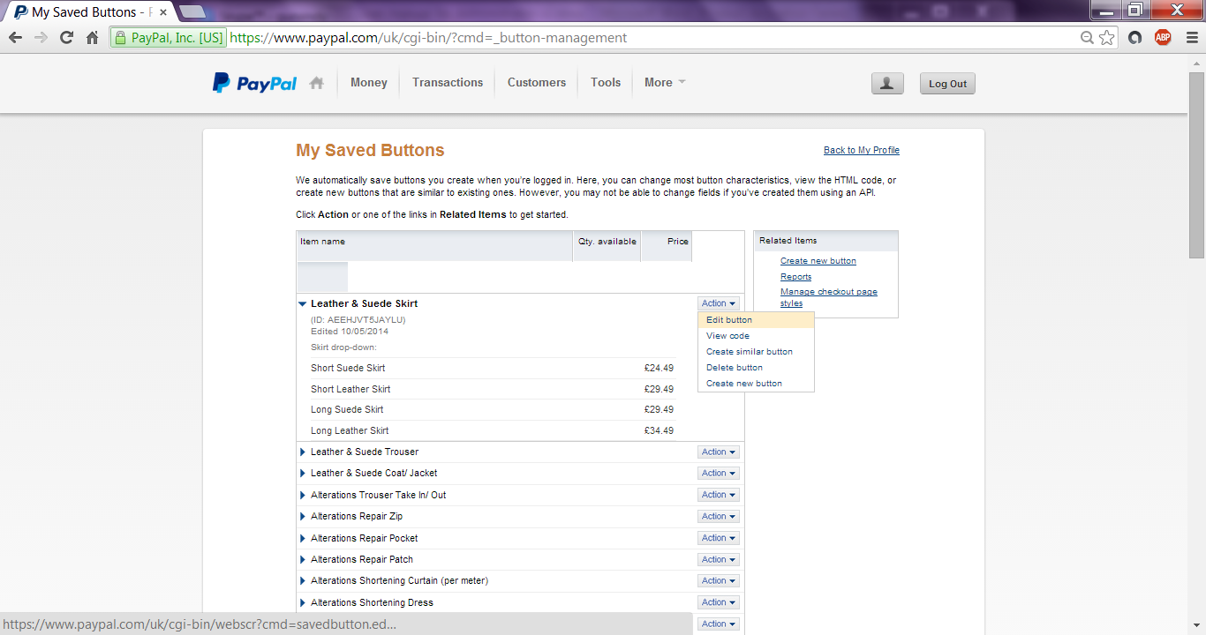

- Edit the service details
- Click Done and Save Changes at the bottom of the page.
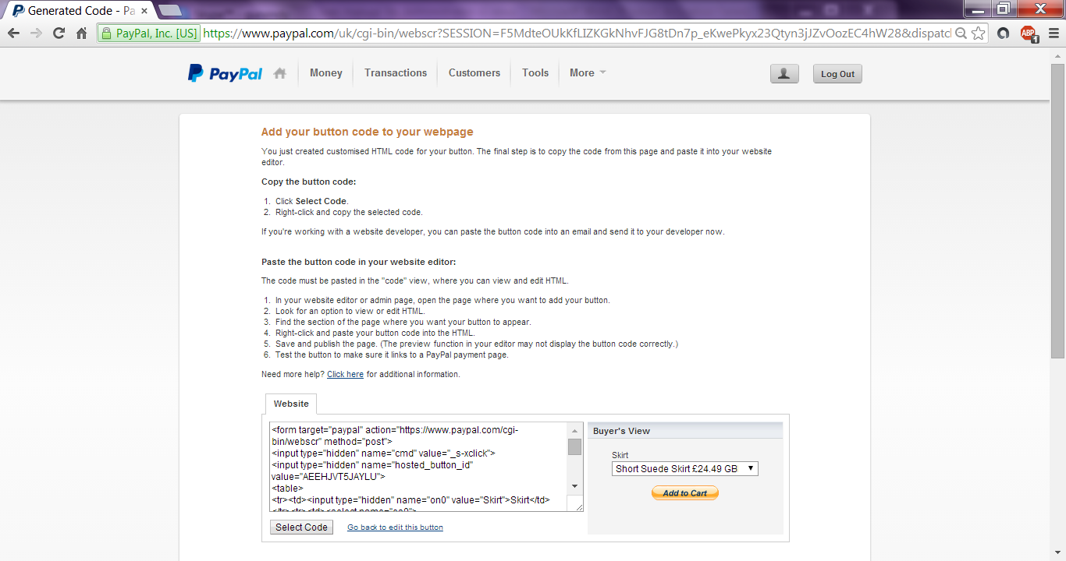
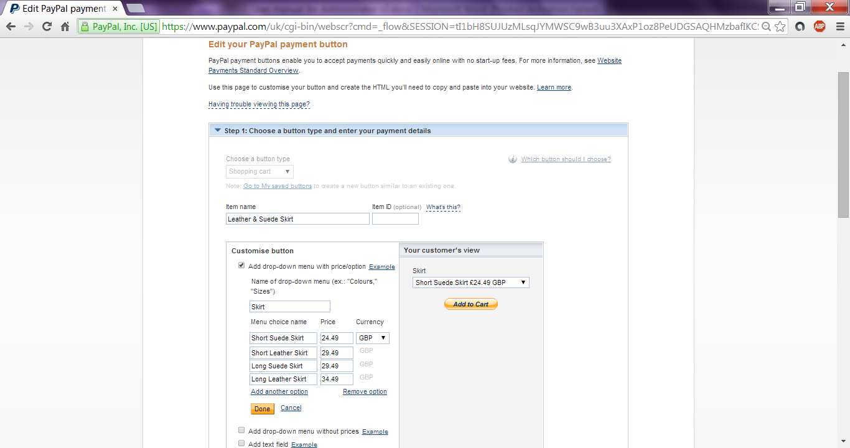
- The following code in the box is required to be pasted in the HTML code (order.jsp) for the change to be displayed on the order page. This will allow direct access of the service items to connect with PayPal ensuring secure payments. Once the user is finished with editing services, the user can then Log Out on the right top corner.

